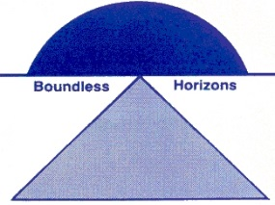 | Wanaaring Public School  O’Grady Street Wanaaring N.S.W. 2840  Phone: (02) 6874 7769 Fax: (02) 6874 7713

Welcome Back to Term 4
Dear Parents/Carers,

I hope everyone had a good holiday. Welcome back to Term 4. Week 1 has already been a busy week.

Some things to remember:
If your child/ren is going to be away from school please let the school know in advance, if you know in advance. If they have been away sick, on return to school can you please send them in with a written note explaining why they were away.

As it is getting hot, please apply sun-cream on your child/ren before they come to school. We will re-apply sun-cream just before we go out for lunch and recess.

As we are coming into snake weather teachers at Wanaaring Public School are going to thoroughly check play areas before students are able to go and play. To possibly assist with snake safety, I am going to see what the Department of Education says about funding to keep anti snake venom at Wanaaring Public School. I definitely am not promising anything. I will inform you when I know.

I know it is swimming weather, but currently the school pool is not fit for swimming in. I am doing my best to sort this situation out and get the pool clean. This job is not proving easy at the moment as the pool pump is broken. I have already had people in to look at it and it is a work in progress, but not an easy fix. I don’t think it is going to be ready to swim in for at least a few weeks. I will keep you all updated. I do apologise for this situation and hope it will be sorted out as soon as possible.

In other exciting news Miss Sylvie McNab welcomed a new arrival into her family. She had a baby girl named Isla Mae Hill. She arrived on Sunday 7th October 2018. She was 3.55kg, so 7 pounds, 13 ounces and 51cm long. Sylvie and Isla are both doing well. She is going to visit Wanaaring Public School after her little girl has had all the normal health injections.

Kind Regards,

Nicola Mathews
Relieving Principal
Wanaaring Public School
Friday, 19th October 2018
__________________________________________________________________________________

